Phil. 8650: Seminar in the Philosophy of Science
Scientific Realism
Spring 2021
Prof. Christopher Pincock
Monday 12:40-3:25pm (University Hall 353)

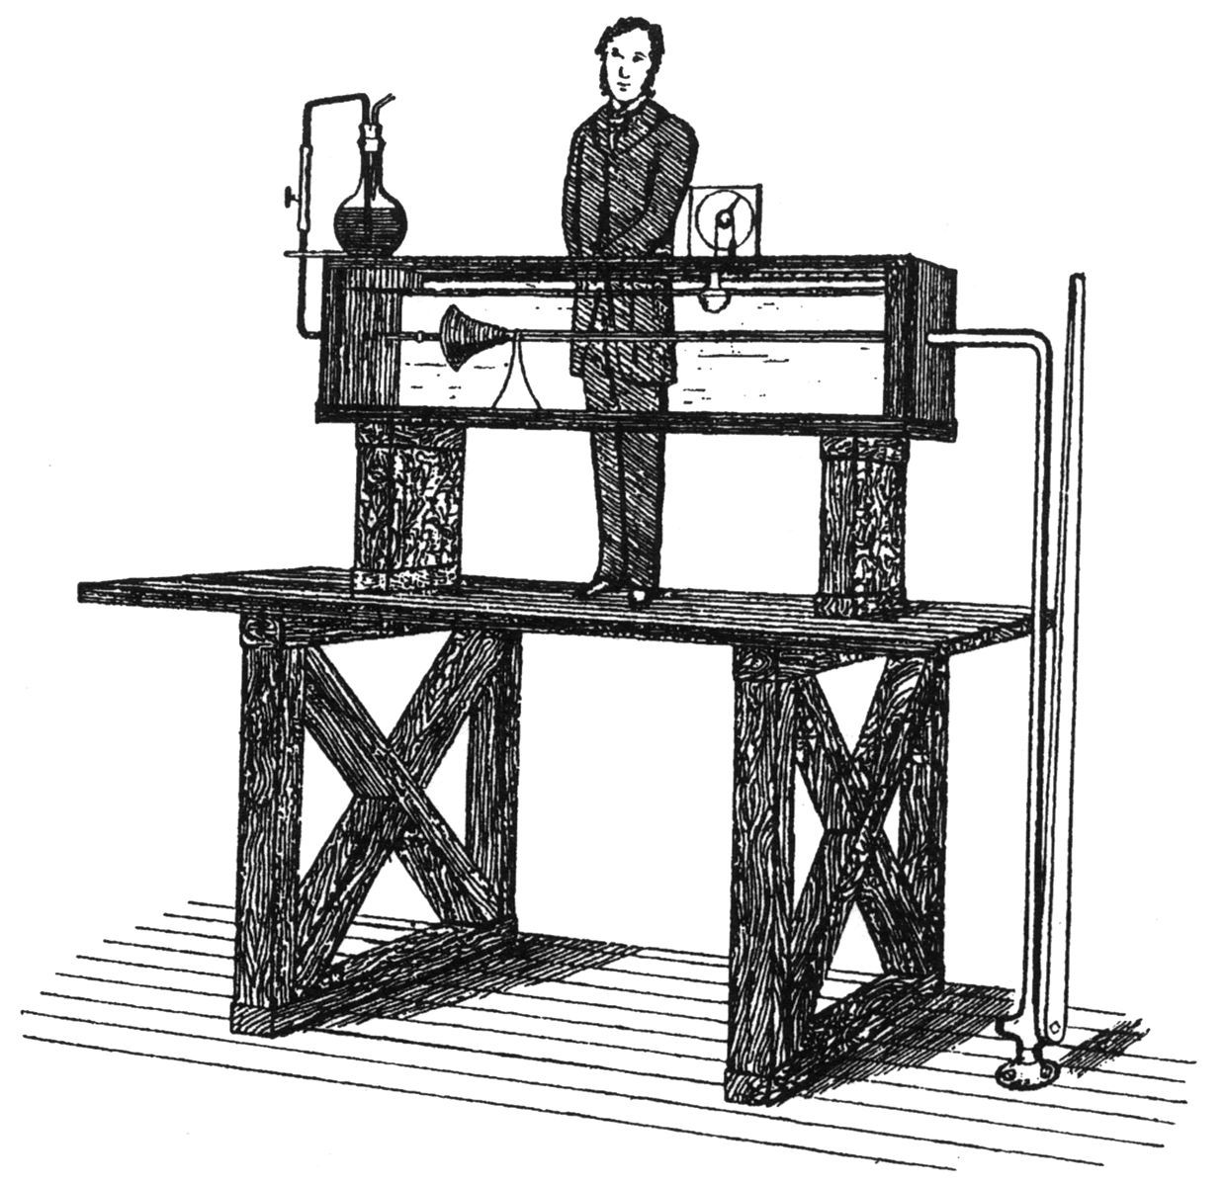

This seminar will consider some of the most influential arguments for and against scientific realism. A scientific realist claims that scientists often come to know features of the world, even features that relate to unobservable entities such as electrons. The most important argument in favor of realism is sometimes called the “no miracles argument”: the truth of our best science is the only explanation of the success of science. One objection to this argument is that when success is measured in terms of accurate predictions, there are many successful theories that we now recognize to be false. This seminar will begin with a careful consideration of some versions of the no miracles argument, with special emphasis on the limited form of realism defended by Stathis Psillos. We will then consider two more recent approaches to scientific realism. Anjan Chakravartty argues that realism requires a specific epistemic stance, but there are several stances incompatible with realism that are equally rational. Michela Massimi argues that the best form of realism is perspectival so that genuine knowledge is always situated with respect to historical and social context. We will see to what extent these alternatives to traditional scientific realism are best seen as improved versions of realism or rejections of realism.

